CSC205 – HCI Course Project

## Overview

The programming project for this semester will be to create an interface to a course schedule database. The data to be provided is the course schedule for Geneva for the 2021 Fall semester. Each course will contain the same data that is shown in my.Geneva and seen below

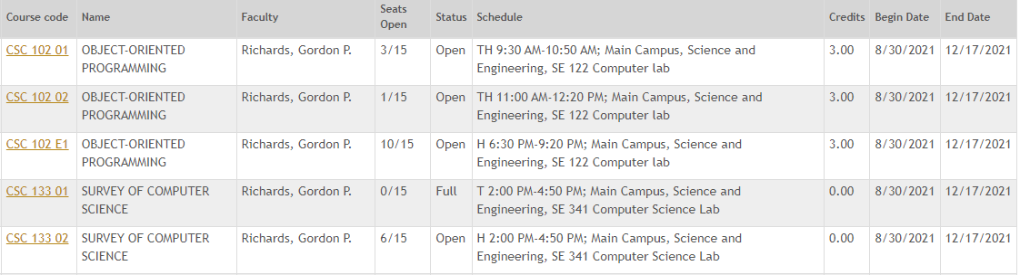

Data fields provided:

* Department
* Course Number
* Section Course Name
* Faculty
* Seats Open
* Total Seats
* Course Status
* Day(s) meeting
* Start Time
* End Time
* Campus
* Building
* Room
* Credits
* Course Begin Date
* Course End Date

## The Project

You will create two web pages for this project

1. Course listing that is filterable and sortable
2. Course Details page that provides complete information about the course

There will be four deliverables for this project. Each will be uploaded into GitHub by the due date.

**Deliverable 0 – Basic Setup**

Successful completion of this deliverable includes:

1. Sending me your GitHub account name
2. Showing me that you have your development environment setup
   1. Git on your computer
   2. Editor / IDE of your choosing

**Deliverable 1 – Search Results screen**

For deliverable 1, you will be provided with a sample set of course data (ten or twenty courses with details) that will be hardcoded into your file. You will use a subset of this data to complete the Search Results Screen.

Applying the principles that we are learning in class, determine what information is important to show for each class on this results screen. You will want to consider cognitive load and basic principles of interaction design as you do your layout.

Along with your code files, submit a text document that includes your reasons for what you did with the results screen.

**Deliverable 2 – Course Details screen**

For this deliverable you will create a screen that shows all of the information you have available for a given course. Data for a course or two will be provided for you to use to programmatically populate your course details layout.

Apply the same principles as you did for deliverable 1 but also address any social or emotional considerations in your design and implementation.

Along with your code files, submit a text document that includes your reasons for what you did with the details screen.

**Deliverable 3 – Dynamic Data**

This deliverable will add dynamic data to your project. You will:

1. Eliminate the hard-coded data from your files and instead use AJAX to query the course data and display the whole listing in your browser
2. Add a filtering capability where you can type CSC, for example, and it will dynamically show only course listings with the characters csc (case-insensitive) in them.
3. Gracefully handle an error condition where there is no data to display. For example, you filter on xyz and that string isn’t found in the data. Instead of showing an empty grid, provide a message that tells them to try something different.
4. Add the capability to email the faculty member. The data will include some real email addresses and some “filler” addresses that won’t go to anybody (we don’t want to be emailing the entire humanities department as part of the class project.)

# Grading

The project will be graded based on meeting the functional requirements, designed using principles we are learning in class and adding features that go beyond the requirements. If you meet all of the given requirements and show inclusion of interaction design principles, you will get a maximum score of 85%. Anything extra that you implement and any extra creativity that you include will boost your score up to a possible 100% score.